ACCUKNOX – ASSIGNMENT 1
Problem Statement 1

Anish Sarkar
B.Tech (AI & ML), Netaji Subhash Engineering College, Kolkata
GitHub: https://github.com/ans036

Repos referenced:
• Schizophrenia EEG – https://github.com/ans036/Schizophrenia_EEG
• Chronic disease DB – https://github.com/ans036/chronic-disease-burden-sqlite

========================================
Q1. FETCH BOOKS FROM API, STORE IN SQLITE, DISPLAY
========================================

If I got this in a real project, I'd treat it like a tiny ETL step: pull JSON from an API, validate/clean it, persist to SQLite, and then query back to verify. That's pretty close to how I handled patient-level data during my Doyen Diagnostics internship, just with fewer features and no labels.

Assumptions

• Endpoint: https://api.example.com/books
• Response shape:

[
{"title": "Clean Code", "author": "Robert C. Martin", "year": 2008},
{"title": "Deep Learning", "author": "Ian Goodfellow", "year": 2016}
]

Schema and approach

I create a single table with a uniqueness constraint so the script can safely be re-run.

CREATE TABLE IF NOT EXISTS books (
id INTEGER PRIMARY KEY AUTOINCREMENT,
title TEXT NOT NULL,
author TEXT NOT NULL,
year INTEGER,
UNIQUE(title, author)
);

At a high level:

• Hit the API with requests.
• Clean the JSON (strip whitespace, cast year to int, drop empty rows).
• Insert into SQLite using INSERT OR IGNORE.
• Select and print everything in a simple, readable format.

Code

import requests
import sqlite3
from contextlib import closing

API_URL = "https://api.example.com/books"
DB_PATH = "books.db"

def fetch_books_from_api(url: str):
resp = requests.get(url, timeout=10)
resp.raise_for_status()
data = resp.json()

books = []
for item in data:
title = (item.get("title") or "").strip()
author = (item.get("author") or "").strip()
year = item.get("year")
year = int(year) if year is not None else None
if title and author:
books.append((title, author, year))
return books

def init_db(db_path: str):
with closing(sqlite3.connect(db_path)) as conn, conn:
conn.execute(
"""
CREATE TABLE IF NOT EXISTS books (
id INTEGER PRIMARY KEY AUTOINCREMENT,
title TEXT NOT NULL,
author TEXT NOT NULL,
year INTEGER,
UNIQUE(title, author)
)
"""
)

def insert_books(db_path: str, books):
with closing(sqlite3.connect(db_path)) as conn, conn:
conn.executemany(
"""
INSERT OR IGNORE INTO books (title, author, year)
VALUES (?, ?, ?)
""",
books,
)

def get_books(db_path: str):
with closing(sqlite3.connect(db_path)) as conn:
cur = conn.execute(
"SELECT title, author, year FROM books ORDER BY year DESC"
)
return cur.fetchall()

def main():
init_db(DB_PATH)
books = fetch_books_from_api(API_URL)
insert_books(DB_PATH, books)

print("Books in database:\n")
for title, author, year in get_books(DB_PATH):
print(f"- {title} by {author} ({year})")

if __name__ == "__main__":
main()

========================================
Q2. FETCH STUDENT SCORES, COMPUTE AVERAGE, PLOT BAR CHART
========================================

For anything even slightly tabular, I default to pandas + matplotlib. That's exactly what I used in my Schizophrenia EEG and highway-traffic projects for analyzing feature distributions and comparing model performance across runs.

Assumptions

• Endpoint: https://api.example.com/student-scores
• Response:

[
{"student": "Alice", "score": 88},
{"student": "Bob", "score": 76},
{"student": "Charlie", "score": 92}
]

Steps

• Fetch JSON with requests.
• Convert to a DataFrame, drop rows with missing values, coerce scores to numeric.
• Compute and print the mean score.
• Plot a bar chart with student on the x-axis and score on the y-axis, and write the image to scores.png.

Code

import requests
import pandas as pd
import matplotlib.pyplot as plt

SCORES_API = "https://api.example.com/student-scores"

def load_scores(url: str) -> pd.DataFrame:
resp = requests.get(url, timeout=10)
resp.raise_for_status()
data = resp.json()
df = pd.DataFrame(data)
df = df.dropna(subset=["student", "score"])
df["score"] = pd.to_numeric(df["score"], errors="coerce")
df = df.dropna(subset=["score"])
return df

def plot_scores(df: pd.DataFrame, output_path: str = "scores.png"):
plt.figure(figsize=(8, 4))
plt.bar(df["student"], df["score"], color="steelblue")
plt.xlabel("Student")
plt.ylabel("Score")
plt.title("Test scores by student")
plt.ylim(0, 100)

for idx, val in enumerate(df["score"]):
plt.text(idx, val + 1, f"{val:.1f}", ha="center", fontsize=8)

plt.tight_layout()
plt.savefig(output_path, dpi=150)
plt.close()

def main():
df = load_scores(SCORES_API)
avg = df["score"].mean()
print(f"Average score: {avg:.2f}")
plot_scores(df)

if __name__ == "__main__":
main()

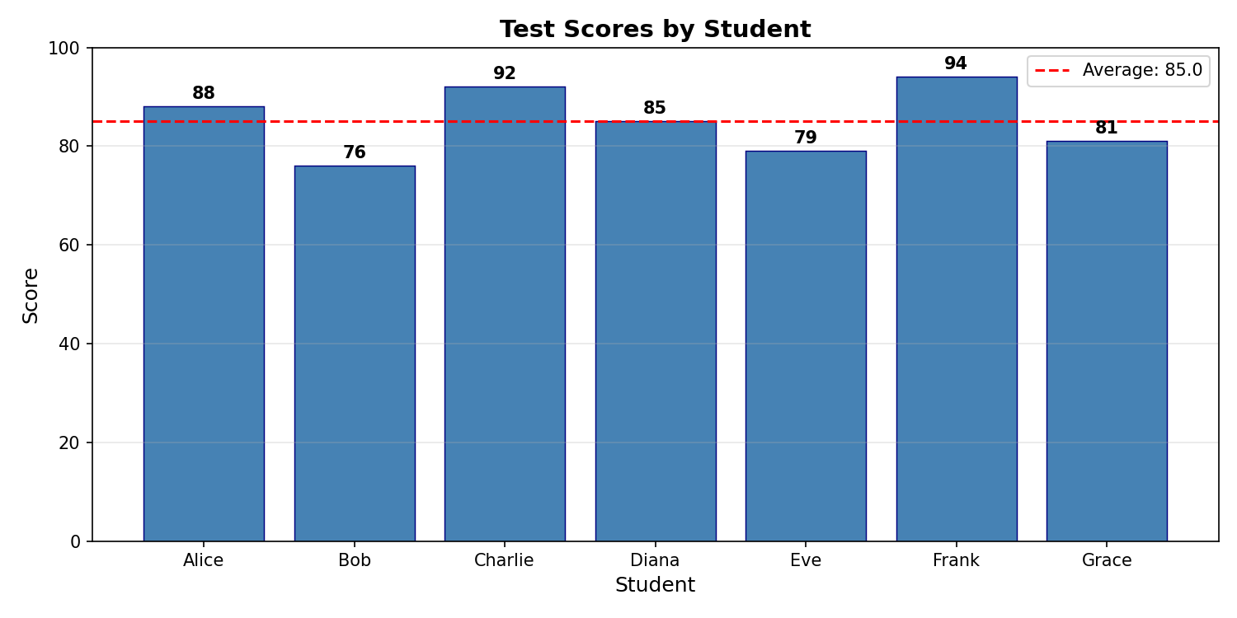

========================================
Q3. READ USERS FROM CSV AND INSERT INTO SQLITE
========================================

CSV → SQLite is something I've done many times: for EEG features, traffic samples, and clinical data. Here the requirements are light, so csv + sqlite3 are more than enough.

Assumptions

• CSV file: users.csv
• Columns: at least name, email.

Plan

• Read users.csv using csv.DictReader.
• Clean name and email (strip whitespace, lowercase email).
• Create a users table with UNIQUE(email) so imports are idempotent.
• Use INSERT OR IGNORE to skip duplicates.

Code

import csv
import sqlite3
from contextlib import closing
from pathlib import Path

CSV_FILE = Path("users.csv")
DB_PATH = "users.db"

def init_user_db(db_path: str):
with closing(sqlite3.connect(db_path)) as conn, conn:
conn.execute(
"""
CREATE TABLE IF NOT EXISTS users (
id INTEGER PRIMARY KEY AUTOINCREMENT,
name TEXT NOT NULL,
email TEXT NOT NULL UNIQUE
)
"""
)

def read_users_from_csv(csv_path: Path):
users = []
with csv_path.open("r", newline="", encoding="utf-8") as f:
reader = csv.DictReader(f)
for row in reader:
name = (row.get("name") or "").strip()
email = (row.get("email") or "").strip().lower()
if name and email:
users.append((name, email))
return users

def insert_users(db_path: str, users):
with closing(sqlite3.connect(db_path)) as conn, conn:
conn.executemany(
"INSERT OR IGNORE INTO users (name, email) VALUES (?, ?)",
users,
)

def main():
if not CSV_FILE.exists():
raise FileNotFoundError(f"{CSV_FILE} not found")

init_user_db(DB_PATH)
users = read_users_from_csv(CSV_FILE)
insert_users(DB_PATH, users)
print(f"Processed {len(users)} users from CSV (duplicates ignored).")

if __name__ == "__main__":
main()

========================================
Q4. MOST COMPLEX PYTHON CODE
========================================

Most complex Python code

I'd pick my Schizophrenia Classification using EEG project as my most complex Python code so far. The pipeline:

• Extracts PSD/DE/SE features from EEG signals and generates around 50k scalp heatmaps.
• Uses a Chrononet-inspired CNN to classify patients, with training, validation, and experiment management scripts.
• Reaches around 99% classification accuracy on the dataset reported in my resume.

Code link: https://github.com/ans036/Schizophrenia_EEG

========================================
Q5. MOST COMPLEX DATABASE CODE
========================================

Most complex database code

The most structured database work I've done so far is in this small chronic disease burden tracking demo:

https://github.com/ans036/chronic-disease-burden-sqlite

It defines a realistic SQLite schema (patients, clinicians, chronic conditions, visits, lab_results, risk_scores, alerts) and includes Python scripts to seed sample patients, compute a rule-based chronic disease-burden score, and generate alerts. The schema and logic mirror the kind of patient-level data I handled in my disease-burden prediction internship at Doyen Diagnostics, but here I focus purely on the database layer instead of the ML model.

